HACKER RANK (PYTHON QUESTIONS)

1 . 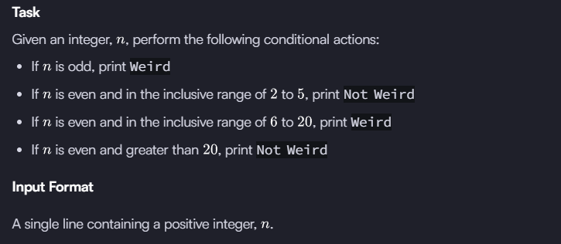
Sample Input 0
3
Sample Output 0
Weird

Answer :

n = int(input().strip())

if n % 2 != 0:
print("Weird")
elif 2 <= n <= 5:
print("Not Weird")
elif 6 <= n <= 20:
print("Weird")
else:
print("Not Weird")

2 . Task :
The provided code stub reads two integers from STDIN, a and b . Add code to print three lines where:
- The first line contains the sum of the two numbers.
- The second line contains the difference of the two numbers (first - second).
- The third line contains the product of the two numbers.
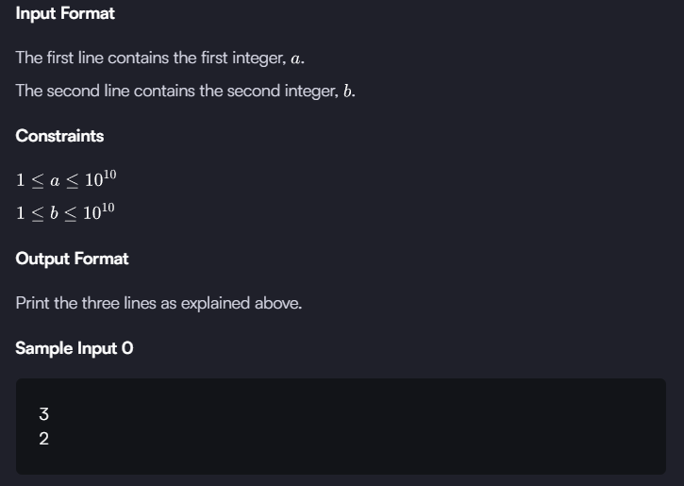

Answer :
a = int(input().strip())
b = int(input().strip())

print(a + b) # sum
print(a - b) # difference
print(a * b) # product

3 . Task :
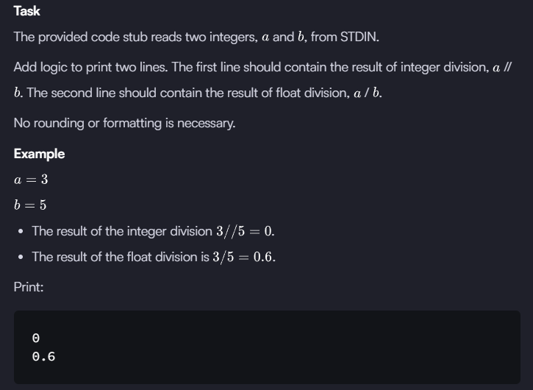

Source code :
a = int(input().strip())
b = int(input().strip())

# Integer division
print(a // b)

# Float division
print(a / b)

4 . Task :
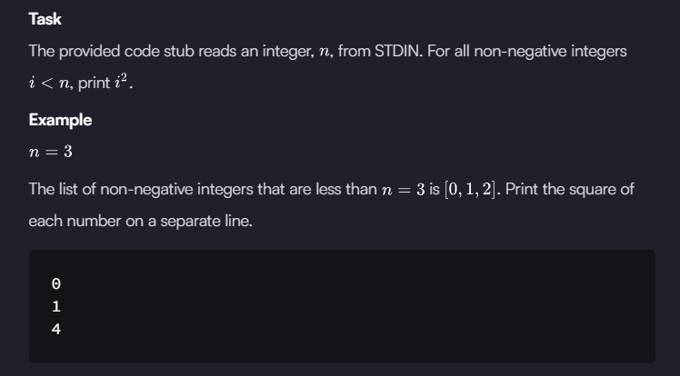

Source code :
n = int(input().strip())

for i in range(n):
print(i * i)

5 . Task :
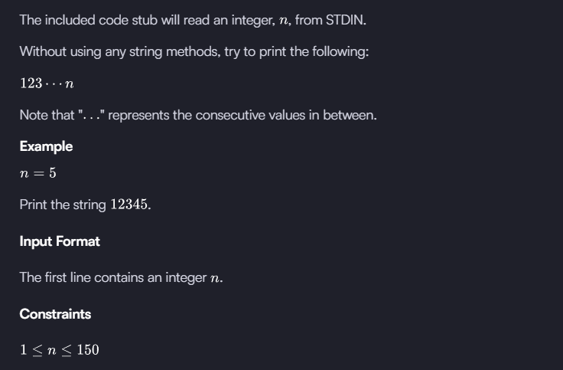

Source code :
n = int(input().strip())

for i in range(1, n + 1):
print(i, end="")

6 . 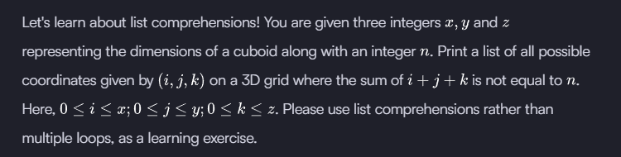
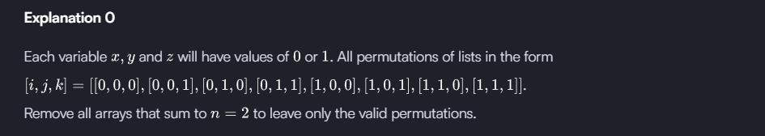
Sample Input 1
2
2
2
2
Sample Output 1
[[0, 0, 0], [0, 0, 1], [0, 1, 0], [0, 1, 2], [0, 2, 1], [0, 2, 2], [1, 0, 0], [1, 0, 2], [1, 1, 1], [1, 1, 2], [1, 2, 0], [1, 2, 1], [1, 2, 2], [2, 0, 1], [2, 0, 2], [2, 1, 0], [2, 1, 1], [2, 1, 2], [2, 2, 0], [2, 2, 1], [2, 2, 2]]

Source code :
x = int(input())
y = int(input())
z = int(input())
n = int(input())

result = [[i, j, k]
for i in range(x + 1)
for j in range(y + 1)
for k in range(z + 1)
if i + j + k != n]

print(result)

7 . 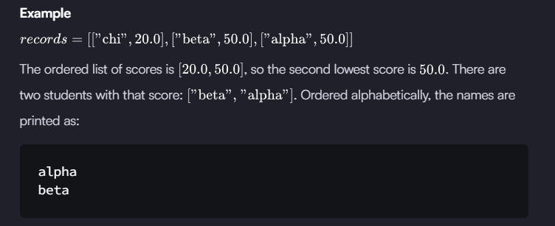
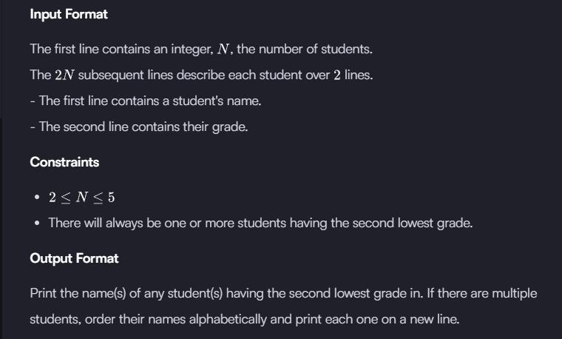
Sample Input 0
5
Harry
37.21
Berry
37.21
Tina
37.2
Akriti
41
Harsh
39
Sample Output 0
Berry
Harry

Source Code :
records = []
for _ in range(int(input().strip())):
name = input().strip()
score = float(input().strip())
records.append([name, score])

# Extract unique scores and sort them
scores = sorted(set([s for _, s in records]))
second_lowest = scores[1]

# Collect names with the second lowest score
names = [n for n, s in records if s == second_lowest]

# Print names alphabetically
for name in sorted(names):
print(name)

8 . Consider a list (list = []). You can perform the following commands:
- insert i e: Insert integer at position .
- print: Print the list.
- remove e: Delete the first occurrence of integer .
- append e: Insert integer at the end of the list.
- sort: Sort the list.
- pop: Pop the last element from the list.
- reverse: Reverse the list.
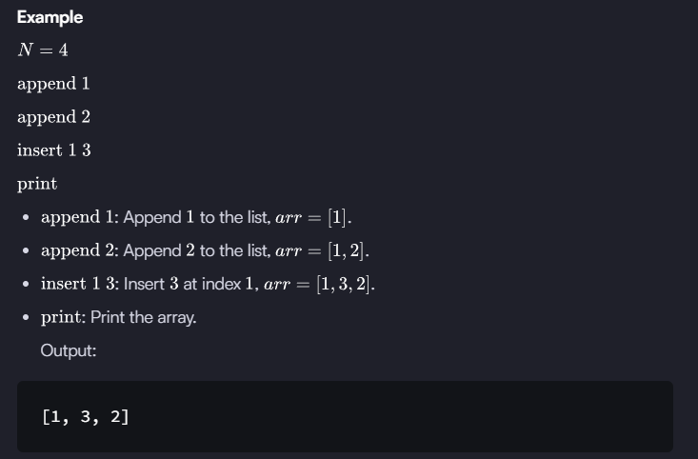

Source Code :
N = int(input())
arr = []

for _ in range(N):
cmd = input().split()
if cmd[0] == "insert":
arr.insert(int(cmd[1]), int(cmd[2]))
elif cmd[0] == "print":
print(arr)
elif cmd[0] == "remove":
arr.remove(int(cmd[1]))
elif cmd[0] == "append":
arr.append(int(cmd[1]))
elif cmd[0] == "sort":
arr.sort()
elif cmd[0] == "pop":
arr.pop()
elif cmd[0] == "reverse":
arr.reverse()

9 . n Python, a string can be split on a delimiter.
Example:
>>> a = "this is a string"
>>> a = a.split(" ") # a is converted to a list of strings.
>>> print a
['this', 'is', 'a', 'string']
Joining a string is simple:
>>> a = "-".join(a)
>>> print a
this-is-a-string
Task :
You are given a string. Split the string on a " " (space) delimiter and join using a - hyphen.
Function Description
Complete the split_and_join function in the editor below.
split_and_join has the following parameters:
- string line: a string of space-separated words
Returns
- string: the resulting string
Input Format
The one line contains a string consisting of space separated words.
Sample Input
this is a string
Sample Output
this-is-a-string

Source Code :
def split_and_join(line):
# write your code here
return "-".join(line.split(" "))
if __name__ == '__main__':
line = input()
result = split_and_join(line)
print(result)

10 . An extra day is added to the calendar almost every four years as February 29, and the day is called a leap day. It corrects the calendar for the fact that our planet takes approximately 365.25 days to orbit the sun. A leap year contains a leap day.
In the Gregorian calendar, three conditions are used to identify leap years:
- The year can be evenly divided by 4, is a leap year, unless:
  - The year can be evenly divided by 100, it is NOT a leap year, unless:
    - The year is also evenly divisible by 400. Then it is a leap year.
This means that in the Gregorian calendar, the years 2000 and 2400 are leap years, while 1800, 1900, 2100, 2200, 2300 and 2500 are NOT leap years. Source
Task
Given a year, determine whether it is a leap year. If it is a leap year, return the Boolean True, otherwise return False.
Note that the code stub provided reads from STDIN and passes arguments to the is_leap function. It is only necessary to complete the is_leap function.
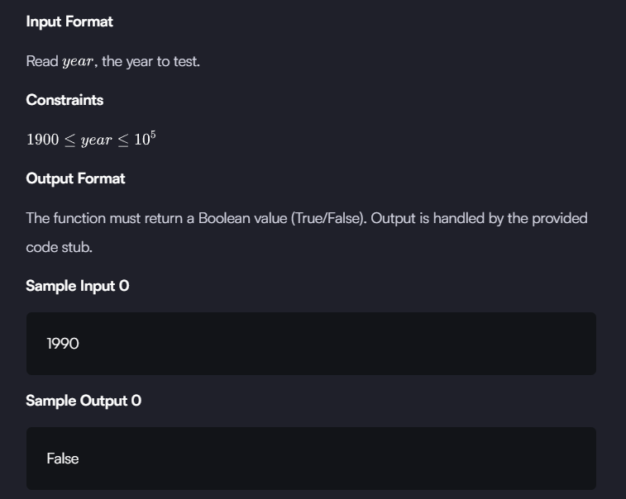

Source code :

def is_leap(year):
leap = False

if (year % 4 == 0 and year % 100 != 0) or (year % 400 == 0):
leap = True

return leap
year = int(input())
print(is_leap(year))

